UNIT-IV:
Principles of Good Screen Design:

Human considerations in screen Design:
A well-designed screen:
· Reflects the capabilities, needs, and tasks of its users.
· Is developed within the physical constraints imposed by the hardware on which it is displayed.
· Effectively utilizes the capabilities of its controlling software.
· Achieves the business objectives of the system for which it is designed.
How to Distract the Screen User:
- Unclear captions and badly worded questions. These cause hesitation, and rereading, in orde to determine what is needed or must be provided. They may also be interpreted incorrectl causing errors.
- Improper type and graphic emphasis. Important elements are hidden. Emphasis is drawn awa from what is important to that which is not important.
- Misleading headings. These also create confusion and inhibit one’s ability to see existin relationships.
- Information requests perceived to be irrelevant or unnecessary. The value of what one doing is questioned, as is the value of the system.
- Information requests that require one to backtrack and rethink a previous answer, or loo ahead to determine possible context. Inefficiency results, and mistakes increase.
- Cluttered, cramped layout. Poor layout creates a bad initial impact and leads to more errors. may easily cause system rejection.
- Poor quality of presentation, legibility, appearance, and arrangement. Again, this degrade performance, slowing the user down and causing more errors.
What Screen Users Want:
- An orderly, clean, clutter-free appearance.
- An obvious indication of what is being shown and what should be done with it.
- Expected information located where it should be.
- A clear indication of what relates to what, including options, headings, captions, data.
A clear indication of when an action can make a permanent change in the data or system.
What Screen Users Do?
hen interacting with a computer, a person
.Identifies a task to be performed or need to be fulfilled: The task may be very structured or sem ructured or structured with free form activities.
.Decides how the task will be completed or the need fulfilled: set of transaction screens will be use he proper transaction is identified and the relevant screen series retrieved.
.Manipulates the computer’s controls: To perform the task or satisfy the need, the keyboard, mous nd other similar devices are used
.Gathers the necessary data:Screens information is collected from its source through forms o oworker and placed on the screen, through control manipulation.
.Forms judgments resulting in decisions relevant to the task or need:Structured transactions wi equire minimal decision-making. Semi-structured transactions, in addition, may require decisions suc s: Which set of screens, from all available,
Interface Design Goals:
- To make an interface easy and pleasant to use, then, the goal in design is to:
  - Reduce visual work.
  - Reduce intellectual work.
  - Reduce memory work.
  - Reduce motor work.
  - Minimize or eliminate any burdens or instructions imposed by technology.

Test for a Good Design :
- Can all screen elements be identified by cues other than by reading the words that make them up?
- A simple test for good screen design does exist. A screen that passes this test will hav surmounted the first obstacle to effectiveness.
- The test is this: Can all screen elements (field captions, data, title, headings, text, types o controls, and so on) be identified without reading the words that identify or comprise them? Th is, can a component of a screen be identified through cues independent of its content?
- If this is so, a person’s attention can quickly be drawn to the part of the screen that is relevant that moment. People look at a screen for a particular reason, perhaps to locate a piece of information such as a customer name, to identify the name of the screen, or to find a instructional or error message.

SCREEN MEANING AND PURPOSE:
- Each screen element . . .
- Every control,All text,The screen organization,All emphasis,Each color,Every graphic
- All screen animation,Each message,All forms of feedback
- Must Have meaning to screen users,Serve a purpose in performing tasks.

Organizing Screen Elements Clearly and Meaningfully:
- Visual clarity is achieved when the display elements are organized and presented in meaningfu and understandable ways. A clear and clean organization makes it easier to recognize screen’ essential elements and to ignore its secondary information when appropriate.

Consistency:
- Provide real-world consistency. Reflect a person’s experiences, expectations, work convention and cultural conventions.
- Provide internal consistency. Observe the same conventions and rules for all aspects of a interface screen, and all application or Web site screens, including:
- Operational and navigational procedures.
- Visual identity or theme.
- Component, Organization, Presentation,Usage, Locations.
- Follow the same conventions and rules across all related interfaces.
- Deviate only when there is a clear benefit for the user.
- Quite simply, consistency greatly aids learning. It establishes an expectation

Ordering of Screen Data and Content:
- Divide information into units those are logical, meaningful, and sensible.
- Organize by the degree interrelationship between data or information.
- Provide an ordering of screen units of information and elements that is prioritized according to th user’s expectations and needs.
- Possible ordering schemes include:
— Conventional/Sequence of use/ Frequency of use/ Function/ Importance/ General to specific.
- Form groups that cover all possibilities.
- Ensure that information that must be compared is visible at the same time.
- Ensure that only information relative to the users tasks or needs is presented on the screen.
- An organizational scheme’s goal is to keep to a minimum the number of information
Technological Considerations in Interface Design
Physical characteristics of the device and device internal software affects the screen interface design. Graphics compatibility for Screen design must be ensured with the following system components:
- System power.
- Screen size.
- Screen resolution.
- Display colors.
- Other display features.
- Development and implementation tools being used.
- System platform being used.
- Platform style guide being used.
Information Retrieval (IR): it concerns with the study of finding required data. i.e., IR helps users to notice data that matches their data desires. Technically, IR studies the organization, acquisition, distribution, storage, and retrieval of data.
HCI Browser
This Browser (HCIB) is designed and implemented by the research team of North Carolina University. It can be downloaded fromhttp://ils.unc.edu/hcibrowser . Following are the features of HCI Browser:
- Web presenting task can be evaluated using this tool.
- designed to assist research activities in HCI through internet
- Can be added as an add-on to the Firefox browser.
- Presents operations for users working in toolbar area.
- Presents the following to the users:
  - administer pre- task questionnaires
  - administer post-task questionnaires
  - event data of searching and browsing activities.
- Saves the following events of browser:
  - Pages loaded
  - Links clicked
  - Window and tab focus changes
  - Open/close windows and tabs
  - Back/forward button clicks
  - Typed URLs
  - Scrolling
  - History/bookmarks menu
- Closes windows automatically.
- Generates a new log file for each process
- Includes the following entries for log file:
  - login time,
  - session id,
  - user id, and
  - Process id
Sketch Tools
Natural art work designers are in need of many free form software tools to express their sketching designs. Right now, existing software tools support pen and ink input to certain extent only. There is a need for intelligent software that can sketch, recognize and convert the natural sketches automatically. Following are such tools:
Inkkit
It is a toolkit used to sketch diagrams. It can be applied over a range of domains.
This software is able to run on a Tablet PC. InkKit consists of the following:
- User Interface
  - The user interface is supported by two main views:
- sketch pages
  - This view supports easy drawing process.
- portfolios.
  - Here this point displays a set of sketches. These sketches can be linked to enable relationships.
- Recognition Engine
  - The power of InkKitis its recognition engine
  - To recognize a specific diagram, it creates a diagram domain and provides examples.
The sketches on this user interface design will normally be converted into both HTML and Java. It is a research tool designed for non-commercial purpose.
Freeform
Freeform tools provide a pen based interface. This tool is mainly used to design controls in the forms by hand sketching.
Requirements :Visual Basic
Features:
- Designs of user interfaces are quicker and easier than creating them with a form builder.
Sketch Node
Sketchnode is a tool used to draw graphs with edges and nodes easily. This tool runs on Tablet PC. Design in this tool can be either done by pen or using drag and drop interaction. Optimization algorithms are used for transforming of not clear graph into a clearer one.
Features:
- supports both low and high fidelity graph rendering.
- Easy design process
- No convolution of images due to optimization.

Intelligent Mind Map
Humans effectively and effortlessly split between drawing and writing ink. This split is difficult to achieve in digital systems. This tool supports for the informal document on the tablet PC by recognition and ink reflow techniques.
TATool
This tool is designed to generate task representations in hierarchical manner. This research was carried out in the Patras University. The original task of this TATool is to analysis the task in interactive system design. It is recognized as a common tool to design hierarchical structures and Visualized objects This tool TATool generates output in XML form and an RTF report. This software runs only on Windows OS. It maps user-system interaction’s recorded events to the process model.

Menus and Navigation Schemes:
Navigation design refers to organizing an interface's navigation to enable users to seamlessly go from one point to another. It provides users with knowledge of where they are in the interface, how they reached there, and where they can go from there.
The user interface (UI) designer should design the navigation in a user-centered way. In other words, it should not be the user's duty to figure out where the interface's features are, as the navigation should walk the user through the system itself.

Structure of navigation design
The UI designer must consider the interface's structure to organize the navigation. The structure is of two main types:
- Local structure
- Global structure
Let's look at how the navigational structures should be designed.

Local structure
Local structure refers to a single screen or page in an interface. A single screen's navigation should tell the user about the following things:
- Where they are: The screen should give enough information to the users about their current location in the interface, and the current state of their goal. For example, a page title shows the users where they currently are in the interface.
- What they can do: All the possible navigation options from the current screen should be clearly visible to the user. Any links or buttons to other pages should be highlighted to communicate their purpose to the user, so they know where they can go further in the interface.
- What will happen: Navigation options should clearly indicate to the user what will happen once they click on them. For example, when icons are used for navigation, they should be accompanied by some explanation or labels. This way, the user does not have to test where it goes by clicking on it, and later be frustrated when the result is not as expected.
The icon is confusing without a label, and does not communicate what will happen
- Where they have been: Users must be given enough feedback about the screens they have visited, and the tasks they have completed, so they don't feel lost. One way designers do this is by displaying breadcrumbs, which show the path of arriving at the current page.

Breadcrumbs displayed under a top navigation bar

Global structure
Global structure refers to how all the screens in an interface link together. There are two ways to organize the global structure:
- Hierarchical organization: The whole system is functionally decomposed into logical groups. This hierarchy helps define the menu options of an interface. An example of such a hierarchy is shown below:
The hierarchical organization of an application
- Network diagram: A network diagram is essential to show links between pages that might not be grouped together in a hierarchical organization. This technique is more task-oriented than a hierarchy. An example of a network of screens is shown below:
A network diagram of an application

Menu
A menu is essentially a graphical control element that accesses various elements on a GUI. It provides users with options and built-in commands to access the features or functionalitieso of an application or program, whether it's web-based or on the user's system.
All menus contain an organized set of items located in a menu bar for easy navigation through the different levels or features of a program. A menu can also be structured as a submenu, depending on its complexity and command structure.

How to access a menu
A menu is also known as a file menu or a file, edit, view menu because these are often the first three options in a drop-down menu, particularly in Windows-based programs. A user can access a program menu via a keyboard shortcut by clicking a mouse or through other input devices. When a selection is made, the menu item is highlighted.
Formatting of Menus

What follows is a series of guidelines for formatting menus.

Consistency

Provide consistency with the user’s expectations.
€
Provide consistency in menu:
- Formatting, including organization, presentation, and choice ordering.
- Phrasing, including titles, choice descriptions, and instructions.
- Choice selection methods.
- Navigation schemes.

Display

If continual or frequent references to menu options are necessary, permanently display the menu in an area of the screen that will not obscure other screen data.
€
If only occasional references to menu options are necessary, the menu may be presented on demand.
€
- Critical options should be continuously displayed, however.

Presentation

Ensure that a menu and its choices are obvious to the user by presenting them with a unique and consistent structure, location, and/or display technique.
€
Ensure that other system components do not possess the same visual qualities as menu choices.

Organization

Provide a general or main menu.
Display:
- All relevant alternatives.
- Only relevant alternatives.
o Delete or gray-out inactive choices.

Match the menu structure to the structure of the task.
- Organization should reflect the most efficient sequence of steps to accomplish a person’s most frequent or most likely goals.
Minimize number of menu levels within limits of clarity.
- For Web sites, restrict it to two levels (requiring two mouse clicks) for fastest performance.
€
Be conservative in the number of menu choices presented on a screen:
- Without logical groupings of elements, limit choices to 4 to 8.
- With logical groupings of elements, limit choices to 18 to 24.

Provide decreasing direction menus, if sensible.
Never require menus to be scrolled.
€
Provide users with an easy way to restructure a menu according to how work is accomplished.
€
In general, the more choices contained on a menu (greater breadth), the less will be its depth; the fewer choices on a menu (less breadth), the greater will be its depth.
€
The advantages of a menu system with greater breadth and less depth are:

o Fewer steps and shorter time to reach one’s objective. o
o Fewer opportunities to wander down wrong paths.
o Easier learning by allowing the user to see relationships of menu items.

A broad menu’s disadvantages are:
€
o A more crowded menu that may reduce the clarity of the wording of choices.

o Increased likelihood of confusing similar choices because they are seen together.

The advantages of greater depth are:
o Less crowding on the menu.
o Fewer choices to be scanned.
o Easier hiding of inappropriate choices.

o Less likelihood of confusing similar choices since there is less likelihood that they will be seen together.
Greater depth disadvantages are:
o More steps and longer time to reach one’s objective.

o More difficulties in learning since relationships between elements cannot always be seen.

o More difficulties in predicting what lies below, resulting in increased likelihood of going down wrong paths or getting lost.
o Higher error rates.

Complexity

Provide both simple and complex menus.
Simple: a minimal set of actions and menus.
Complex: a complete set of actions and menus.

Item Arrangement

Align alternatives or choices into single columns whenever possible.
o Orient for top-to-bottom reading.
o Left-justify descriptions.
If a horizontal orientation of descriptions must be maintained:
o Organize for left-to-right reading.
Ordering

Order lists of choices by their natural order, or
For lists associated with numbers, use numeric order.
For textual lists with a small number of options (seven or less), order by:
o Sequence of occurrence.
o Frequency of occurrence.
o Importance.
o Semantic similarity.
Use alphabetic order for:
o Long lists (eight or more options).
o Short lists with no obvious pattern or frequency.
Separate potentially destructive actions from frequently chosen items.
If option usage changes, do not reorder menus.
Maintain a consistent ordering of options on all related menus.
o For variable-length menus, maintain consistent relative positions.
o For fixed-length menus, maintain consistent absolute positions.
A meaningful ordering is necessary to:
Facilitate search for an item.

Provide information about the structure and relationships among items. o Provide compatibility with the user’s mental model of the item structure. o Enhance the user’s ability to anticipate a choice’s location.

Groupings

Create groupings of items that are logical, distinctive, meaningful, and mutually exclusive.
€
Categorize them in such a way as to:
o Maximize the similarity of items within a category.
o Minimize the similarity of items across categories.
Present no more than six or seven groupings on a screen.
€
Order categorized groupings in a meaningful way.
€
If meaningful categories cannot be developed and more than eight options must be displayed on a screen, create arbitrary visual groupings that:
o Consist of about four or five but never more than seven options.
o Are of equal size.
Separate groupings created through either:
o Wider spacing, or
o A thin ruled line.
Provide immediate access to critical or frequently chosen items.

Line Separators

Separate vertically arrayed groupings with subtle solid lines.
Separate vertically arrayed subgroupings with subtle dotted or dashed lines.
For subgroupings within a category:

o Left-justify the lines under the first letter of the columnized choice descriptions.
o Right-justify the lines under the last character of the longest choice description.

For independent groupings:
o Extend the line to the left and right menu borders.
Phrasing the Menu

A menu must communicate to the user information about:
o The nature and purpose of the menu itself.
o The nature and purpose of each presented choice.
o How the proper choice or choices may be selected.

Menu Titles

Main menu:
- Create a short, simple, clear, and distinctive title, describing the purpose of the entire series of choices.

Submenus:
- Submenu titles must be worded exactly the same as the menu choice previously selected to display them.

General:
- Locate the title at the top of the listing of choices.

- Spell out the title fully using either an:
• Uppercase font.
• Mixed-case font in the headline style.

- Superfluous titles may be omitted.

Menu Choice Descriptions

Create meaningful choice descriptions that are familiar, fully spelled out, concise,and distinctive.

Descriptions may be single words, compound words, or multiple words or phrases.

Exception: Menu bar items should be a single word (if possible).

Place the keyword first, usually a verb.

Use the headline style, capitalizing the first letter of each significant word in the choice description.

Use task-oriented not data-oriented wording.
Use parallel construction.

A menu choice must never have the same wording as its menu title.

Identical choices on different menus should be worded identically.
Choices should not be numbered.
— Exception: If the listing is numeric in nature, graphic, or a list of varying items, it may be numbered.

If menu options will be used in conjunction with a command language, the capitalization and syntax of the choices should be consistent with the command language.

Word choices as commands to the computer.

Menu Instructions

For novice or inexperienced users, provide menu completion instructions.
- Place the instructions in a position just preceding the part, or parts, of the menu to which they apply.
Left-justify the instruction and indent the related menu choice descriptions a minimum of three spaces to the right.

Leave a space line, if possible, between the instructions and the related menu choice descriptions.

- Present instructions in a mixed-case font in sentence style.

For expert users, make these instructions easy to ignore by:
- Presenting them in a consistent location.
- Displaying them in a unique type style and/or color.

Intent Indicators

Cascade indicator:
- To indicate that selection of an item will lead to a submenu, place a triangle or right-pointing solid arrow following the choice.

- A cascade indicator must designate every cascaded menu.

To a window indicator:
- For choices that result in displaying a window to collect more information,
place an ellipsis (. . .) immediately following the choice.
- Exceptions—do not use when an action:

- Causes a warning window to be displayed.
- May or may not lead to a window.
Direct action items:
- For choices that directly perform an action, no special indicator should be placed on the menu.
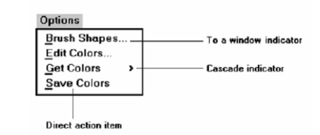

Keyboard Equivalents
To facilitate keyboard selection of a menu choice, each menu item should be assigned a keyboard equivalent mnemonic.

The mnemonic should be the first character of the menu item’s description.
Functions of Menus

a menu can be used to perform several functions, to navigate to a new menu, to execute an action or procedure, to display information, or to input data or parameters

Navigation to a New Menu

Each user selection causes another menu in a hierarchical menu tree to be displayed.

The purpose of each selection is to steer the user toward an objective or goal.

Selection errors may lead the user down wrong paths, and cost time and, perhaps, aggravation, but these errors are nondestructive and usually undoable.

Execute an Action or Procedure

A user selection directs the computer to implement an action or perform a procedure.

The action may be something like opening or closing a file, copying text, or sending a message.

Accidental selection of critical irreversible actions must be prevented in interface design.

Displaying Information

The main purpose of selecting a menu choice may simply be to display information.

The user may be searching for specific information in a database or browsing the Web. The content material and the user’s interests will determine the paths followed.
Menu Context

A menu’s context provides information to keep the user oriented.

Feedback is necessary that tells users where they are in a process, what their past choices were, and possibly how much farther they still have to navigate

Verbal linkage, spatial linkage, or both may be used to provide navigation feedback.

Verbal linkage involves providing, on the current menu screen, a listing of choices made on previous menus that have led to this position. It also involves assuring the user that the displayed menu is the menu desired

Spatial linkage can be accomplished by graphic methods. Each succeeding menu screen can be displayed overlapping the previous menu screen so a succession of choices can be seen in a single view.

Menu Title

A menu’s title provides the context for the current set of choices. The title must reflect the choice selected on the previously displayed menu.

Choice Descriptions

Choice descriptions are the alternatives available to the user.

These descriptions can range from a mnemonic, numeric, or alphabetized listing of choices to single words or phrases to full sentences or more.

Completion Instructions

Completion instructions tell users how to indicate their choices

Explicit instructions may be needed for first time or casual users of a system. Experienced users will find overly verbose instructions unnecessary.

Kinds Of Graphical Menus
1.Menu Bar:
The highest level graphical system menu is commonly called the menu bar.The Menu bar consists of a series of textual words or buttons.These are used to represent the application alternatives or choices to the user.All primary window must have a menu bar.All menu bars must have an associated pull down menu which containing atleast 2 choices.It does not allows the user to turn off the display of the menu bar.The window title will be the menu bar title.It do not display choices that are never available to the user.It separate the bar from the remainder of the screen by a different background.They require the moving pointer from the main working area to select the choices.It consumes a full row of screen space.It usually do not hidden the screen working area.This is called Menu Bar.
2.Pull-Down Menus:
These are the first level menus which is used to provide access to the common and most frequently used application actions that take place on a wide variety of different windows.These are a smaller number of items.No window space is consumed when they are not used.These menus are easy to browse.The items are smaller than full sized buttons.It displays all possible alternatives.Each consists of atleast 2 choices.Title is not necessary for a pull down menu.If a pull down choice leads to another pull down,then it provide a cascade indicator to denote it.This is called Pull-Down Menus.
3.Cascading Menus:
A cascading menu is a sub menu which is derived from a higher level menu,most typically a pull down menu.It don not exceed 3 menu levels that is 2 cascades.This is called Cascading menus.
4.Popup Menus:
The choices may be presented to the user on the screen through popup menus.These menus appear in the working area.They do not use window space when not displayed.No pointer movement is needed if selected by button.They require a special action to see the menu.Their display location may not be consistent.This is called Popup Menus.
5.Tear Off Menus:
A tear off menu is a pull down menu that can be positioned any where on the screen.It possess all the characteristics of a pull down.It require extra steps to retrieve.It hides the screen working area.This is called Tear off menus.
6.Iconic Menus:
It is the picture of menu items or objects in a graphic form.The purpose of an iconic menu is to remind users of the functions,commands,attributes or application choices available.Icons must be meaningful and clear.This is called Iconic Menus.
7.Pie Menus:
A pie menu is a circular representation of menu items.It can be used as a alternative for pull down menu or popup menus.This is called pie menus.
Window Characteristics

A window is seen to possess the following characteristics:

A name or title, allowing it to be identified. o A size in height and width (which can vary).

A state, accessible or active, or not accessible. (Only active windows can have their contents altered.)

Visibility—the portion that can be seen. (A window may be partially or fully hidden behind another window, or the information within a window may extend beyond the window’s display area.)
A location, relative to the display boundary.

Presentation, that is, its arrangement in relation to other windows. It may be tiled, overlapping, or cascading.

Management capabilities, methods for manipulation of the window on the screen.
Its highlight, that is, the part that is selected.
The function, task, or application to which it is dedicated.

The Attraction of Windows

While all the advantages and disadvantages of windows are still not completely understood, windows do seem to be useful in the following ways.

Presentation of Different Levels of Information: A document table of contents can be presented in a window. A chapter or topic selected from this window can be simultaneously displayed in more detail in an adjoining window.
Presentation of Multiple Kinds of Information: Variable information needed to complete a task can be displayed simultaneously in adjacent windows. For example in one window billing can be done and in one window stock maintenance can be done at the same time using windows. Significant windows could remain displayed so that details may be modified as needed prior

Sequential Presentation of Levels or Kinds of Information: Steps to accomplish a task can be sequentially presented through windows. Key windows may remain displayed, but others appear and disappear as necessary. This sequential preparation is especially useful if the information-collection process leads down various paths.

Access to Different Sources of Information: Independent sources of information may have to be accessed at the same time. Independent sources of information may have to be accessed at the same time

Combining Multiple Sources of Information: Text from several documents may have to be reviewed and combined into one. Pertinent information is selected from one window and copied into another.
Components of a Window

Frame

A window will have a frame or border, usually rectangular in shape, to define its boundaries and distinguish it from other windows.

While a border need not be rectangular, this shape is a preferred shape for most people.

Title Bar

The title bar is the top edge of the window, inside its border and extending its entire width.

This title bar is also referred to by some platforms as the caption, caption bar, or title area.

The title bar contains a descriptive title identifying the purpose or content of the window.

Title bar Icon

Located at the left corner of the title bar in a primary window, this button is used in Windows to retrieve a pull-down menu of commands that apply to the object in the window.

It is 16 X 16 version of the icon of the object being viewed.

Window Sizing Buttons

Located at the right corner of the title bar, these buttons are used to manipulate the size of a window.

The leftmost button, the minimize button— inscribed with a short horizontal line toward the bottom of the button—is used to reduce a window to its minimum size, usually an icon. It also hides all associated windows.

The maximize button—typically inscribed with a large box—enlarges a window to its maximum size, usually the entire screen. When a screen is maximized, the restore button replaces the maximize button, since the window can no longer be increased in size.

When these buttons are displayed, use the following guidelines:

When a window does not support a command, do not display its command button.
Window Presentation Styles

The presentation style of a window refers to its spatial relationship to other windows.

There are two basic styles, commonly called tiled or overlapping.

Tiled Windows

Tiled windows derive their name from common floor or wall tile. Tiled windows appear in one plane on the screen and expand or contract to fill up the display surface, as needed.

Most systems provide two-dimensional tiled windows, adjustable in both height and width.

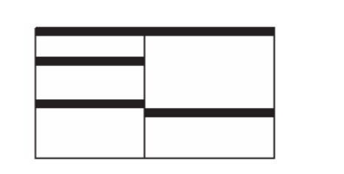
advantages:

The system usually allocates and positions windows for the user, eliminating the necessity to make positioning decisions.

Open windows are always visible, eliminating the possibility of them being lost and forgotten.

Every window is always completely visible, eliminating the possibility of information being hidden.

They are perceived as fewer complexes than overlapping windows, possibly because there are fewer management operations or they seem less “magical.”

They are easier, according to studies, for novice or inexperienced people to learn and use.

They yield better user performance for tasks where the data requires little window manipulation to complete the task.

Disadvantages

Only a limited number can be displayed in the screen area available.

As windows are opened or closed, existing windows change in size. This can be annoying.
As windows change in size or position, the movement can be disconcerting.

As the number of displayed windows increases, each window can get very tiny.
Types of Windows

Primary Window

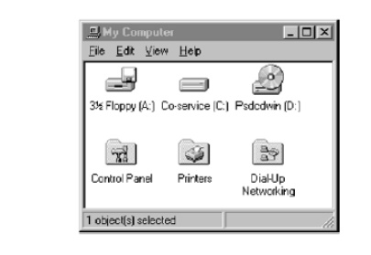
Proper usage:
• Should represent an independent function or application.
• Use to present constantly used window components and controls.
o Menu bar items that are:

• Used frequently.
• Used by most, or all, primary or secondary windows.
o Controls used by dependent windows.
• Use for presenting information that is continually updated.
o For example, date and time.
• Use for providing context for dependent windows to be created.
• Do not:
o Divide an independent function into two or more primary windows.
o Present unrelated functions in one primary window.

It has also been variously referred to as the application window or the main window. In addition, it may be referred to as the parentwindow if one or more child windows exist

Secondary Windows
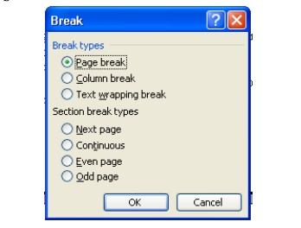

Proper usage:
• For performing subordinate, supplemental, or ancillary actions that are:
o Extended or more complex in nature.
o Related to objects in the primary window.
• For presenting frequently or occasionally used window components.
Important guidelines:
• Should typically not appear as an entry on the taskbar.
• A secondary window should not be larger than 263 dialog units x 263 dialog units.
A dependent secondary window is one common type. It can only be displayed from a command on the interface of its primary window. It is typically associated with a single data object, and appears on top of the active window when requested. It is movable, and scrollable.

An independent secondary window can be opened independently of a primary window—for example, a property sheet displayed when the user clicks the Properties command on the menu of a desktop icon.

Modal and Modeless

Modal:
• Use when interaction with any other window must not be permitted.
• Use for:
o Presenting information.

• For example, messages (sometimes called a message box).
o Receiving user input.

• For example, data or information (sometimes called a prompt box).
o Asking questions.

• For example, data, information, or directions (sometimes called a question box).
• Use carefully because it constrains what the user can do.

Modeless:
• Use when interaction with other windows must be permitted.

• Use when interaction with other windows must be repeated.

Cascading and Unfolding

Cascading:
• Purpose:
o To provide advanced options at a lower level in a complex dialog.

Guidelines:
o Provide a command button leading to the next dialog box with a “To a Window” indicator, an ellipsis (. . . ).

o Present the additional dialog box in cascaded form.
o Provide no more than two cascades in a given path.
o Do not cover previous critical information.

• Title Bar.

• Relevant displayed information.
o If independent, close the secondary window from which it was opened.

Unfolding:
• Purpose:

o To provide advanced options at the same level in a complex dialog.

• Guidelines:
o Provide a command button with an expanding dialog symbol (>>).
o Expand to right or downward.
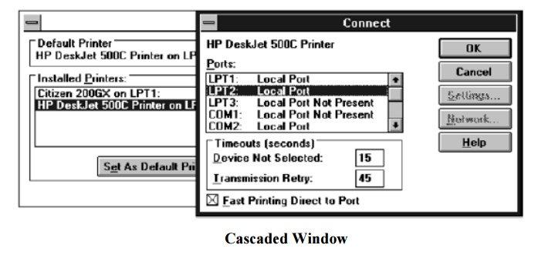
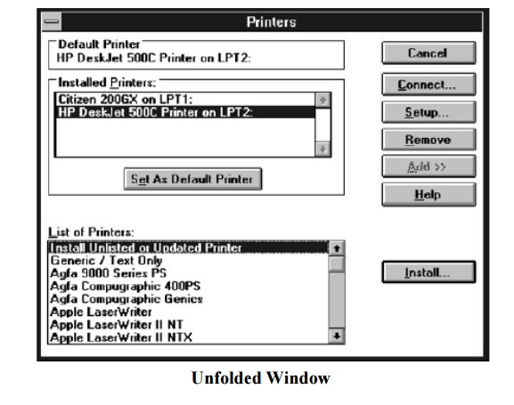

Dialog Boxes
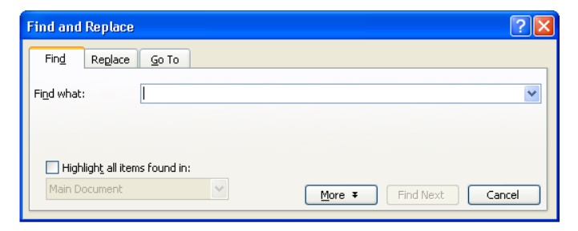
Use for presenting brief messages.
Use for requesting specific, transient actions.
Use for performing actions that:
• Take a short time to complete.
• Are not frequently changed.
Command buttons to include:
• OK.
• Cancel.
• Others as necessary.

Property Sheets and Property Inspectors

Secondary windows provide two other techniques for displaying properties, property
sheets and property inspectors.

Property Sheets
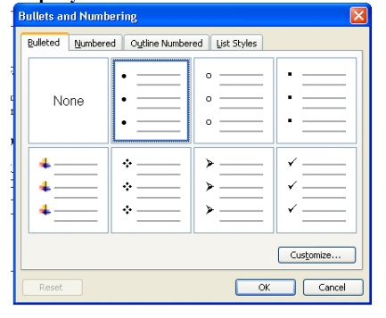

Types of Windows

Primary Window


Proper usage:
• Should represent an independent function or application.
• Use to present constantly used window components and controls.
o Menu bar items that are:

• Used frequently.
• Used by most, or all, primary or secondary windows.
o Controls used by dependent windows.
• Use for presenting information that is continually updated.
o For example, date and time.
• Use for providing context for dependent windows to be created.
• Do not:
o Divide an independent function into two or more primary windows.
o Present unrelated functions in one primary window.

It has also been variously referred to as the application window or the main window. In addition, it may be referred to as the parentwindow if one or more child windows exist

Secondary Windows


Proper usage:
• For performing subordinate, supplemental, or ancillary actions that are:
o Extended or more complex in nature.
o Related to objects in the primary window.
• For presenting frequently or occasionally used window components.
Important guidelines:
• Should typically not appear as an entry on the taskbar.
• A secondary window should not be larger than 263 dialog units x 263 dialog units.
A dependent secondary window is one common type. It can only be displayed from a command on the interface of its primary window. It is typically associated with a single data object, and appears on top of the active window when requested. It is movable, and scrollable.

An independent secondary window can be opened independently of a primary window—for example, a property sheet displayed when the user clicks the Properties command on the menu of a desktop icon.

Modal and Modeless

Modal:
• Use when interaction with any other window must not be permitted.
• Use for:
o Presenting information.

• For example, messages (sometimes called a message box).
o Receiving user input.

• For example, data or information (sometimes called a prompt box).
o Asking questions.

• For example, data, information, or directions (sometimes called a question box).
• Use carefully because it constrains what the user can do.

Modeless:
• Use when interaction with other windows must be permitted.

• Use when interaction with other windows must be repeated.

Cascading and Unfolding

Cascading:
• Purpose:
o To provide advanced options at a lower level in a complex dialog.

Guidelines:
o Provide a command button leading to the next dialog box with a “To a Window” indicator, an ellipsis (. . . ).

o Present the additional dialog box in cascaded form.
o Provide no more than two cascades in a given path.
o Do not cover previous critical information.

• Title Bar.

• Relevant displayed information.
o If independent, close the secondary window from which it was opened.

Unfolding:
• Purpose:

o To provide advanced options at the same level in a complex dialog.

• Guidelines:
o Provide a command button with an expanding dialog symbol (>>).
o Expand to right or downward.



Dialog Boxes

Use for presenting brief messages.
Use for requesting specific, transient actions.
Use for performing actions that:
• Take a short time to complete.
• Are not frequently changed.
Command buttons to include:
• OK.
• Cancel.
• Others as necessary.

Property Sheets and Property Inspectors

Secondary windows provide two other techniques for displaying properties, property
sheets and property inspectors.

Property Sheets

Window Management

Microsoft Windows also provides several window management schemes, a single document interface, a multiple-document interface, workbooks, and projects.

Single-Document Interface

Description:
• A single primary window with a set of secondary windows.

Proper usage:
• Where object and window have a simple, one-to-one relationship.
• Where the object’s primary presentation or use is as a single unit.
• To support alternate views with a control that allows the view to be changed.
• To support simultaneous views by splitting the window into panes.
Advantages:
Most common usage.
Window manipulation is easier and less confusing.
Data-centered approach.
Disadvantage:
Information is displayed or edited in separate windows.

Multiple-Document Interface

Description:
A technique for managing a set of windows where documents are opened into windows.
Contains:
• A single primary window, called the parent.
• A set of related document or child windows, each also essentially a
primary window.
Each child window is constrained to appear only within the parent window.
The child windows share the parent window’s operational elements.
The parent window’s elements can be dynamically changed to reflect the
requirements of the active child window.
Proper usage:
To present multiple occurrences of an object.
To compare data within two or more windows.
To present multiple parts of an application.
Best suited for viewing homogeneous object types.
To clearly segregate the objects and their windows used in a task.
Advantages:
The child windows share the parent window’s interface components (menus,
toolbars, and status bars), making it a very space-efficient interface.
Useful for managing a set of objects.
Provides a grouping and focus for a set of activities within the larger environment of the desktop.

Disadvantages:
Reinforces an application as the primary focus.
Containment for secondary windows within child windows does not exist, obscuring window relationships and possibly creating confusion.
Because the parent window does not actually contain objects, context cannot always be maintained on closing and opening.

The relationship between files and their windows is abstract, making an MDI application more challenging for beginning users to learn.

Confining child windows to the parent window can be inconvenient or inappropriate for some tasks.
The nested nature of child windows may make it difficult for the user to distinguish a child window in a parent window from a primary window that is a peer with the parent window but is positioned on top.

Workbooks

Description:
A window or task management technique that consists of a set of views organized like a tabbed notebook.

It is based upon the metaphor of a book or notebook.
Views of objects are presented as sections within the workbook’s primary
windows; child windows do not exist.

Each section represents a view of data.

Tabs can be included and used to navigate between sections.
Otherwise, its characteristics and behavior are similar to those of the multiple document interface with all child windows maximized.

Proper usage:
To manage a set of views of an object.

To optimize quick navigation of multiple views.
For content where the order of the sections is significant.
Advantages:
Provides a grouping and focus for a set of activities within the larger environment of the desktop.

Conserves screen real estate.

Provides the greater simplicity of the single-document window interface.
Provides greater simplicity by eliminating child window management.
Preserves some management capabilities of the multiple-document interface.
Disadvantage:
Cannot present simultaneous views.

Projects

Description:
A technique that consists of a container: a project window holding a set of objects.

The objects being held within the project window can be opened in primary windows that are peers with the project window.

Visual containment of the peer windows within the project window is not necessary.

Each opened peer window must possess its own menu bar and other interface elements.

Each opened peer window can have its own entry on the task bar.

When a project window is closed, all the peer windows of objects also close.
When the project window is opened, the peer windows of the contained objects are restored to their former positions.
Peer windows of a project may be restored without the project window itself being restored.

Proper usage:
To manage a set of objects that do not necessarily need to be contained.

When child windows are not to be constrained.

web system

A web-based system is an application that is accessed via HTTP. The term web-based is usually used to describe applications that run in a web browser. It can, though, also be used to describe applications that have a very small component of the solution loaded on the client's PC.

he Benefits of Web-Based Systems
Web-based applications used to be very limited in functionality. However, advances in technology, security, and internet speeds have greatly increased the potential scope of web-based systems. Today, we have web-based business accounting systems, web-based CRM systems, a web-based Microsoft Office, and more. Web-based applications offer some significant advantages over native, client-based software. Here are just some of the benefits of web-based apps for business.

